**Active Directory** helps you organize your company's users, computer and more. Your IT admin **uses** AD to organize your company's complete hierarchy from which computers belong on which network, to what your profile picture looks like or which users have access to the storage room

Active Directory (AD) is Microsoft's proprietary directory service. It runs on **Windows Server** and allows administrators to manage permissions and access to network resources. Active Directory stores data as objects. An object is a single element, such as a user, group, application or device, such as a printer.

**Find Your Active Directory Search Base**

1. Select Start > Administrative Tools > **Active Directory** Users and Computers.
2. In the **Active Directory** Users and Computers tree, find and select your domain name.
3. Expand the tree to find the path through your **Active Directory** hierarchy.

**Active directory database** uses the “Extensible Storage Engine (ESE)” which is an indexed and sequential access method (ISAM) **database**. It is uses record-oriented **database** architecture which provides extremely fast access to records. ... The default **active directory database** file location is C:\Windows\NTDS.

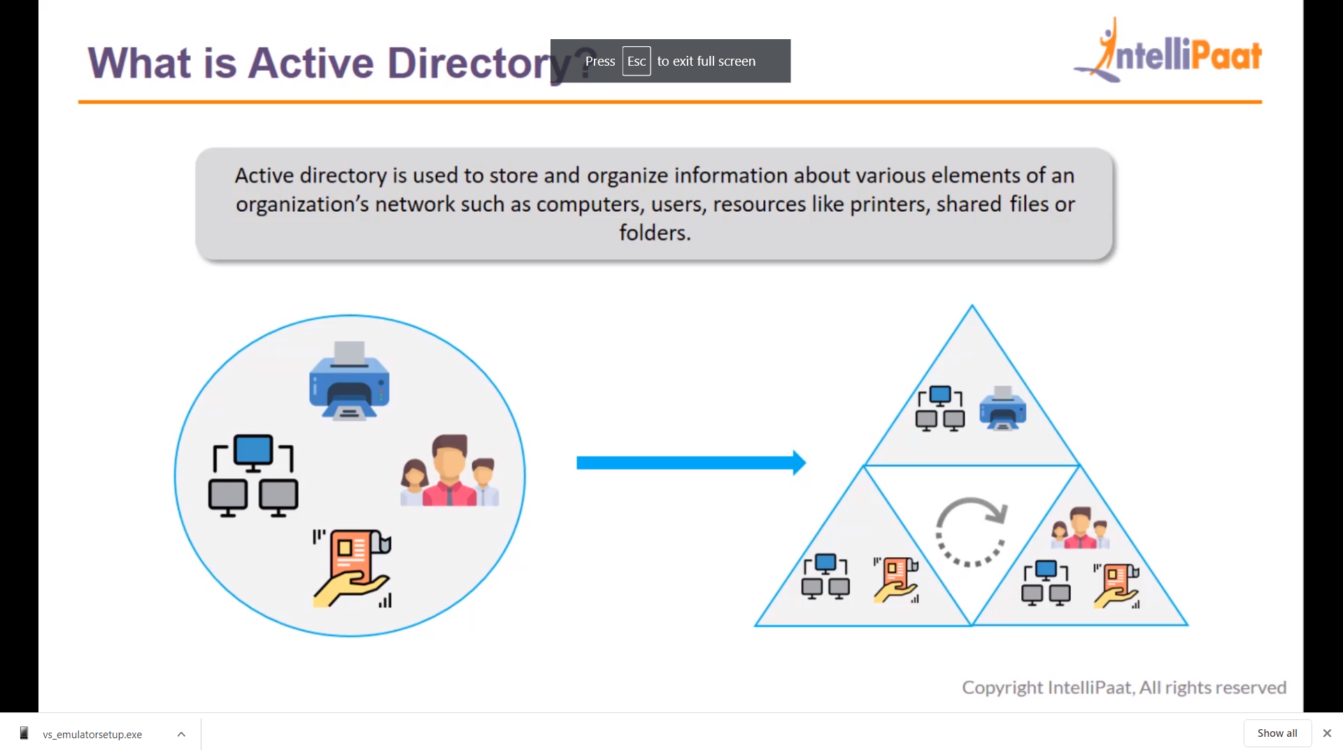

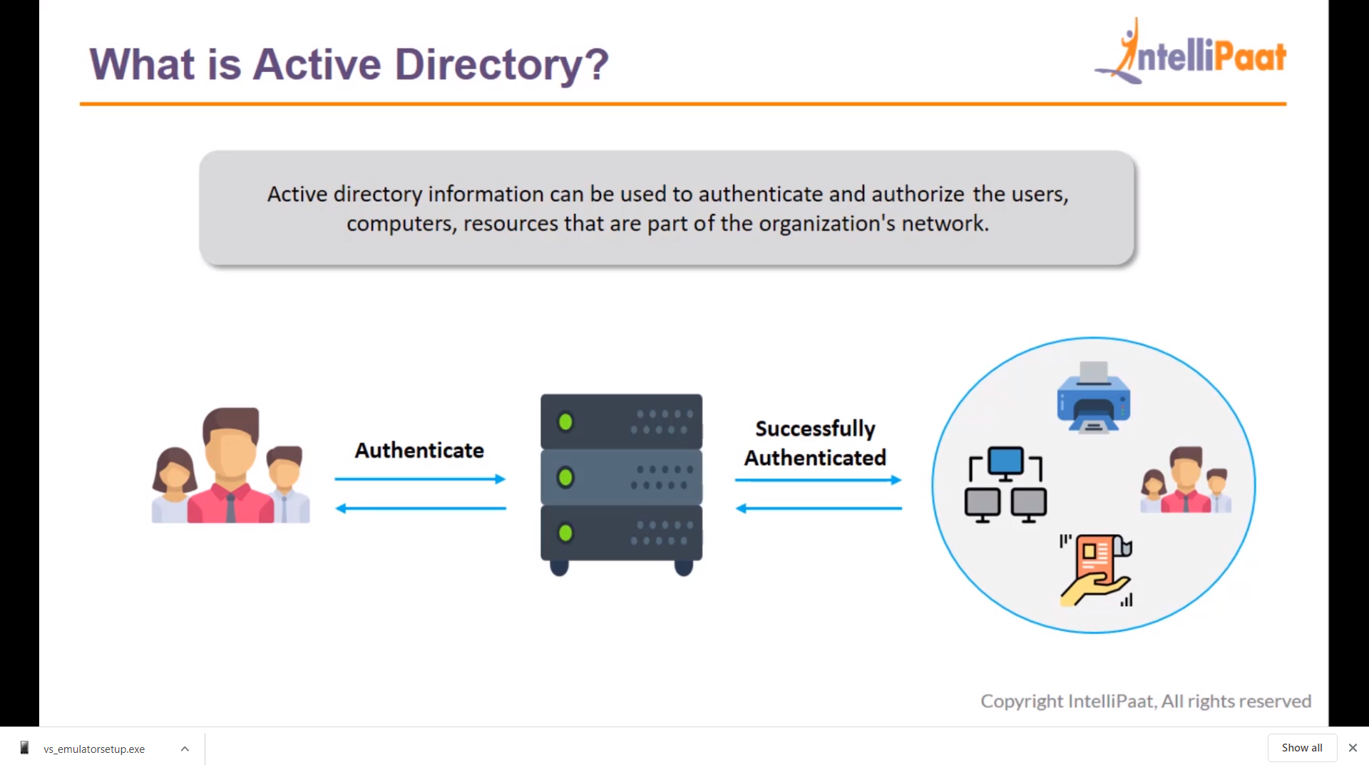

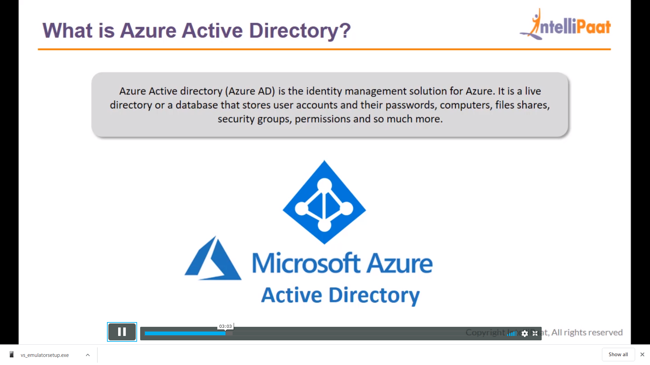

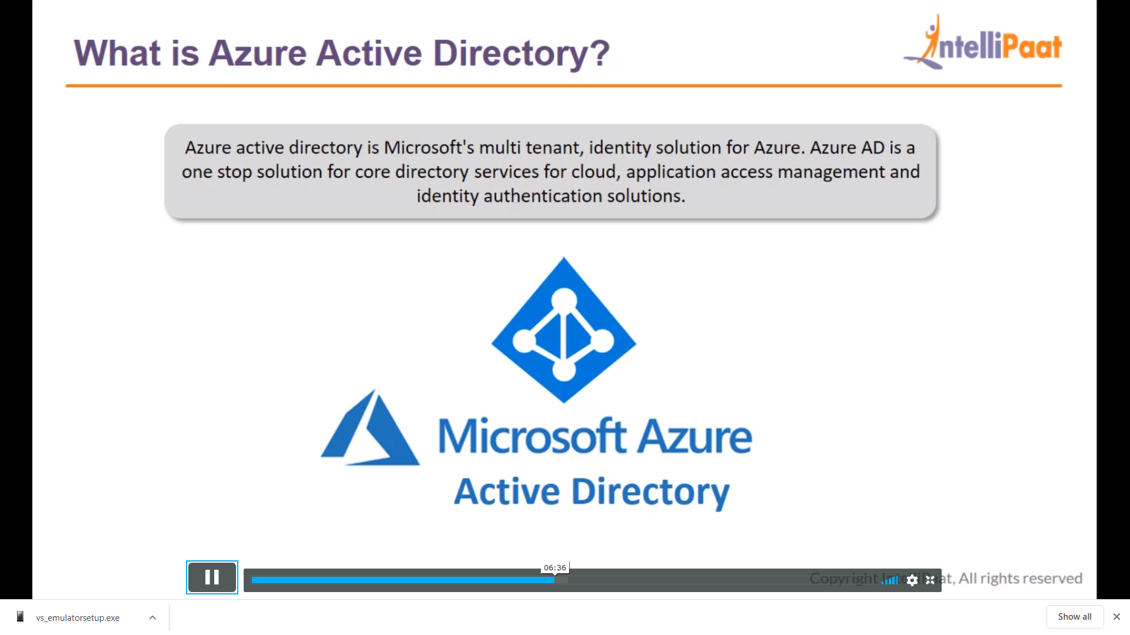

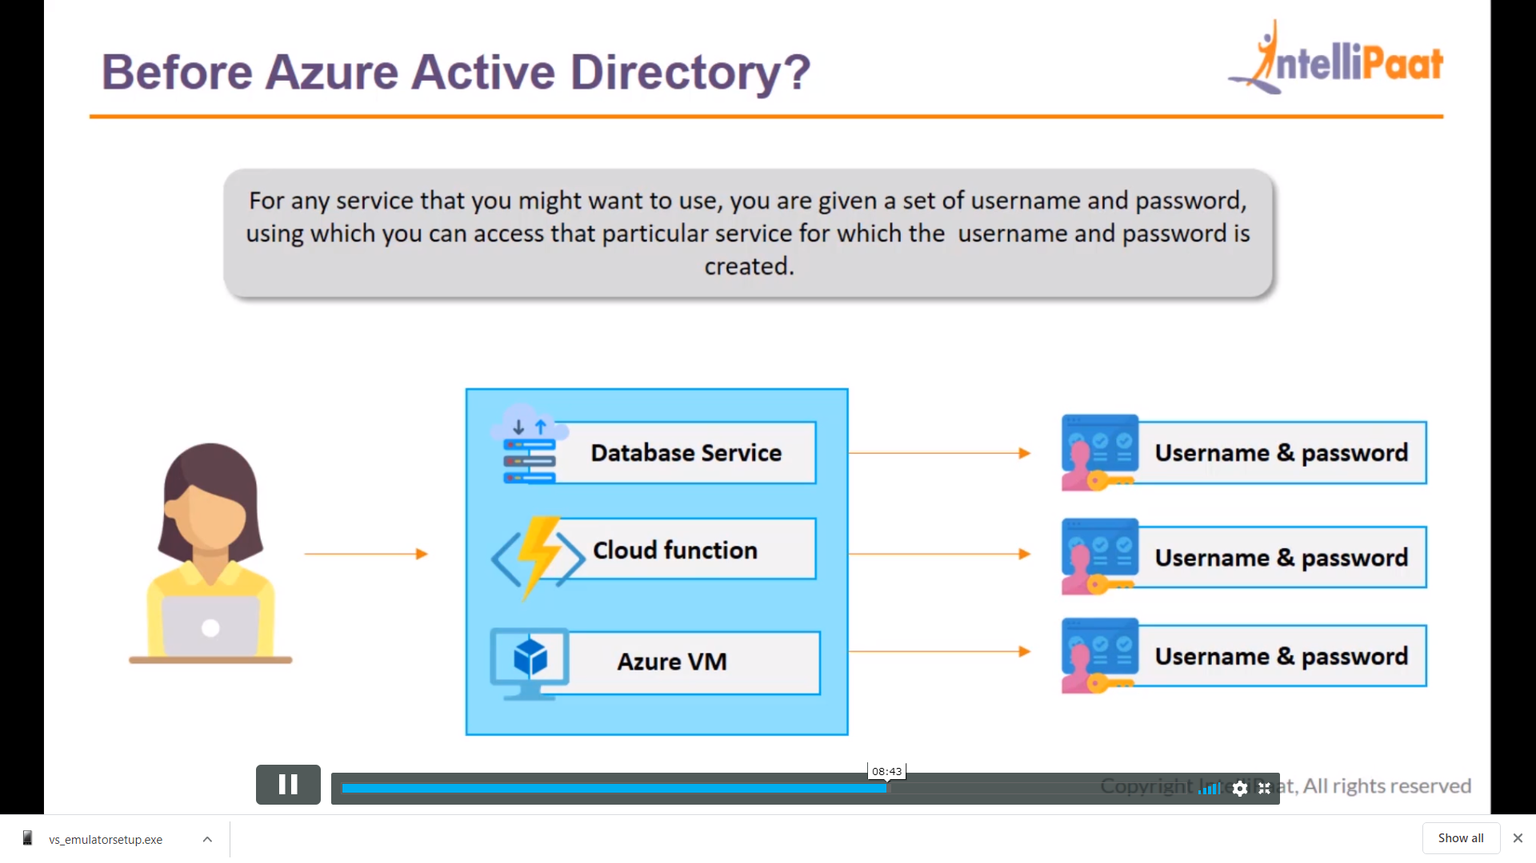

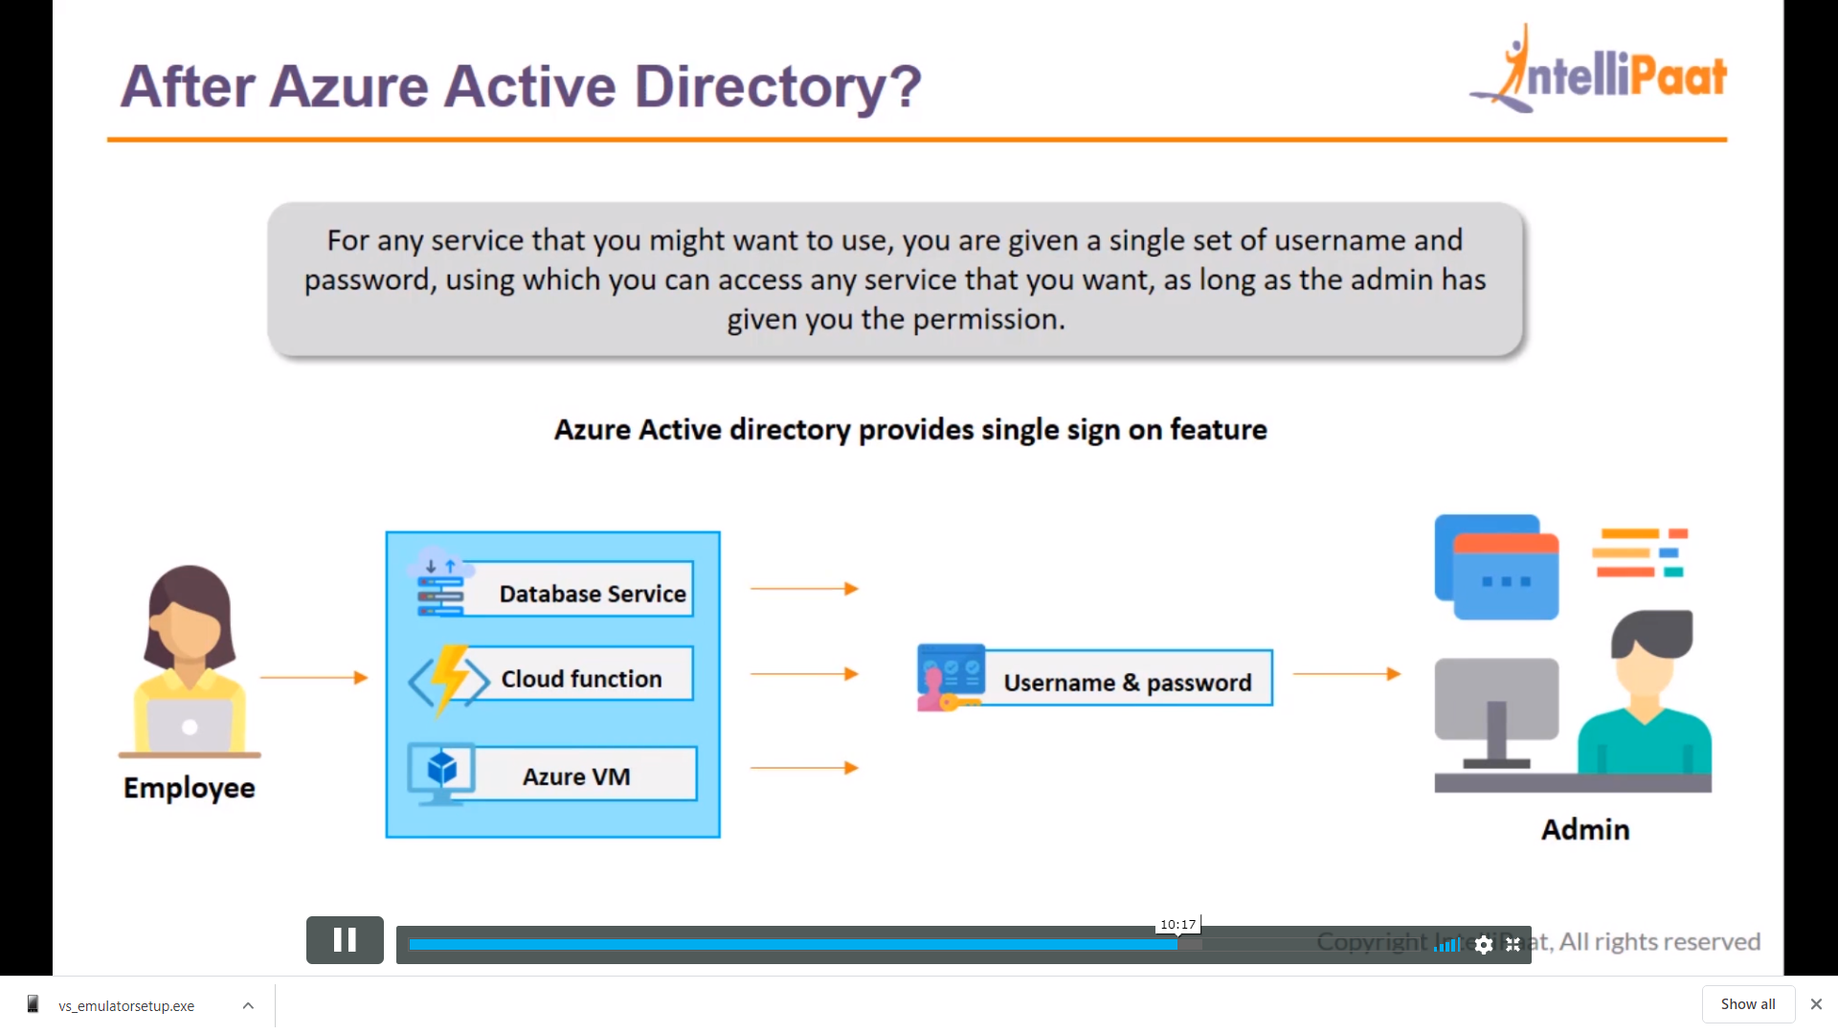



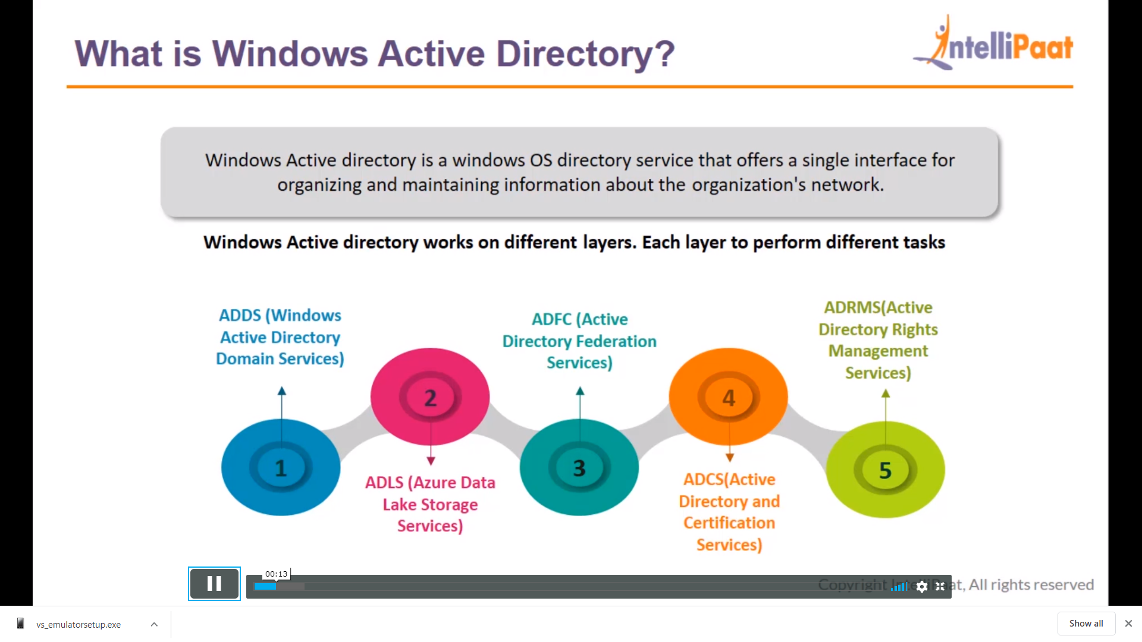

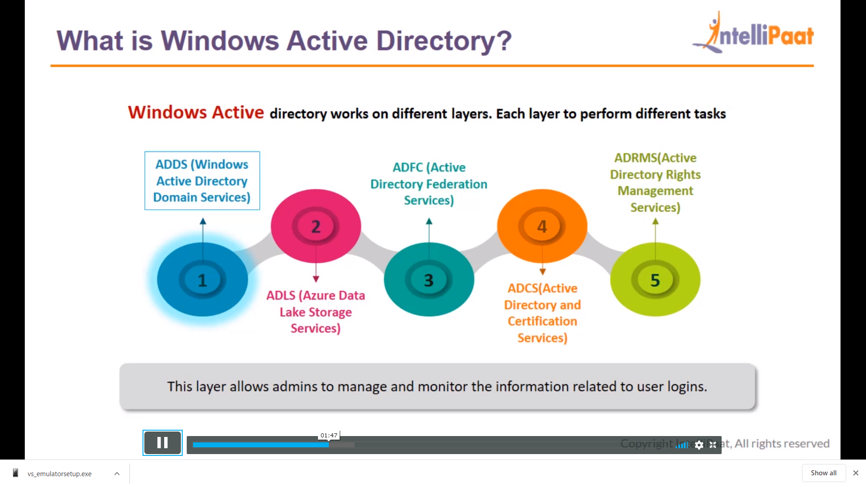

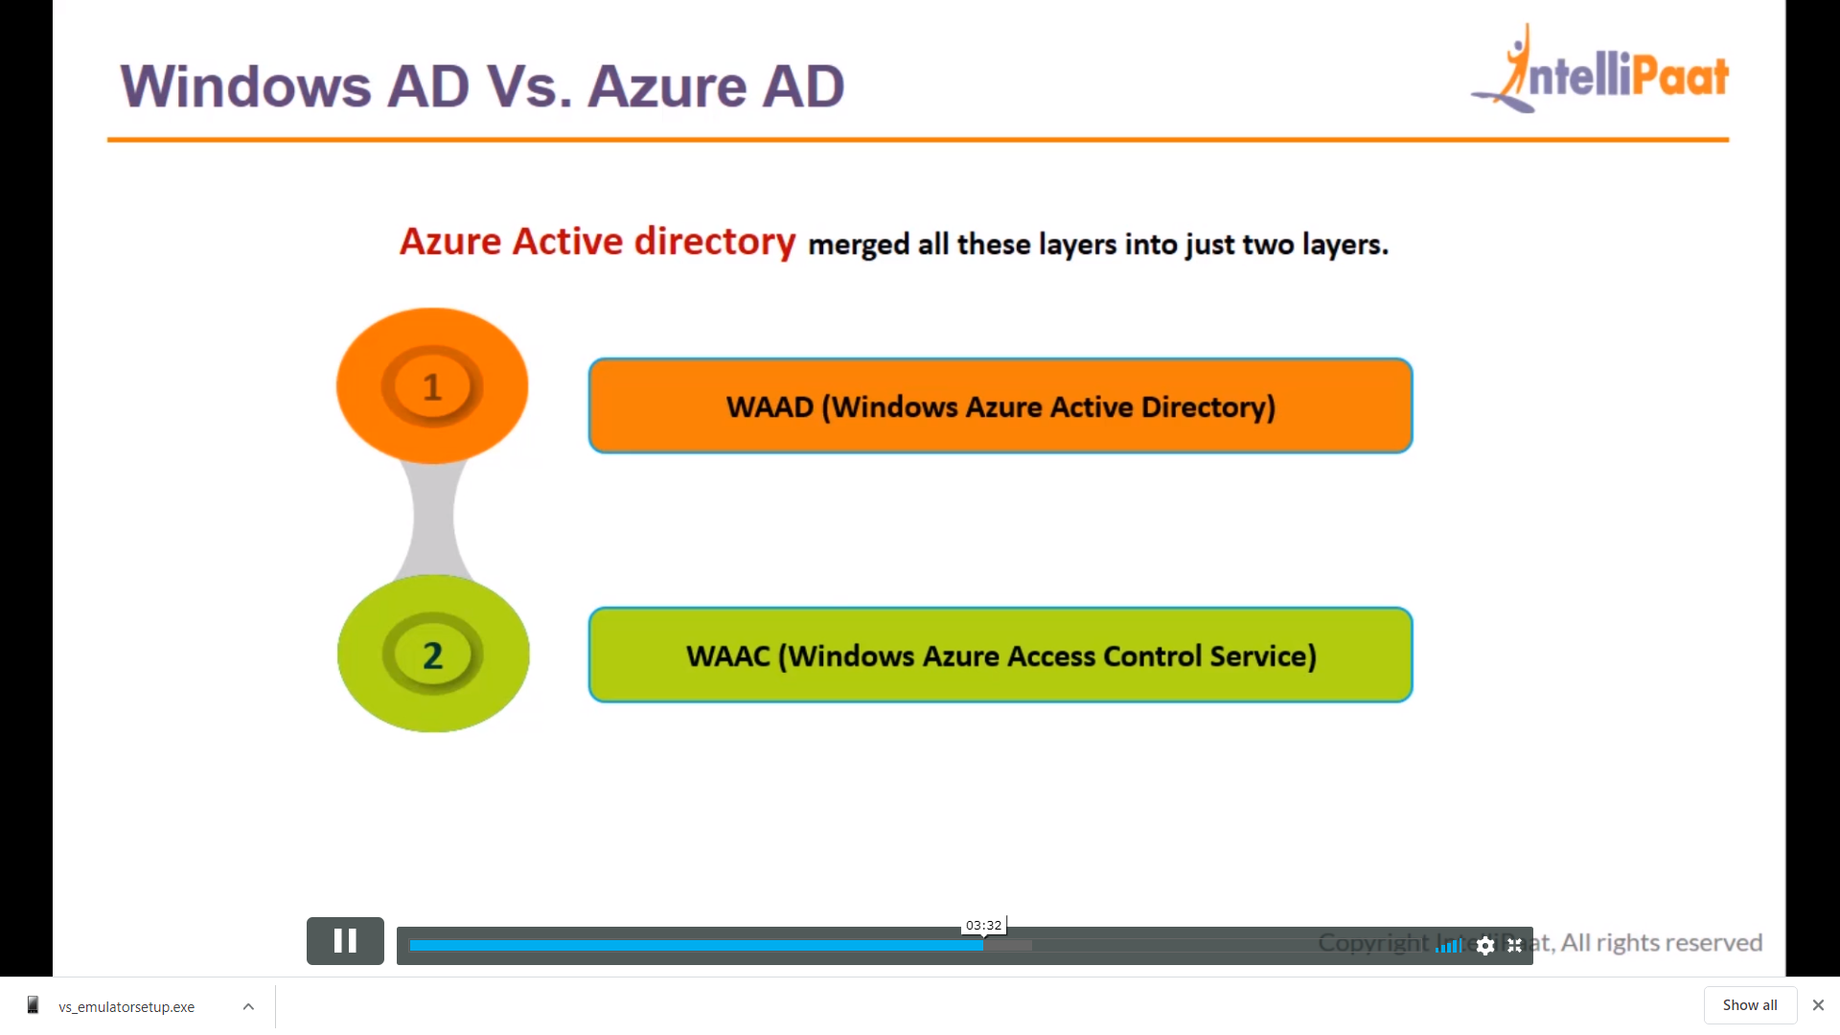

1

